Dear Customer:
Before we trouble shoot your RF issues, we need to collect some information from you side.
Please connect your modem directly to a computer with a network cable.
- Modem information
- Open a browser
- Go to 192.168.100.1
- In the menu, click “DOCSIS WAN”
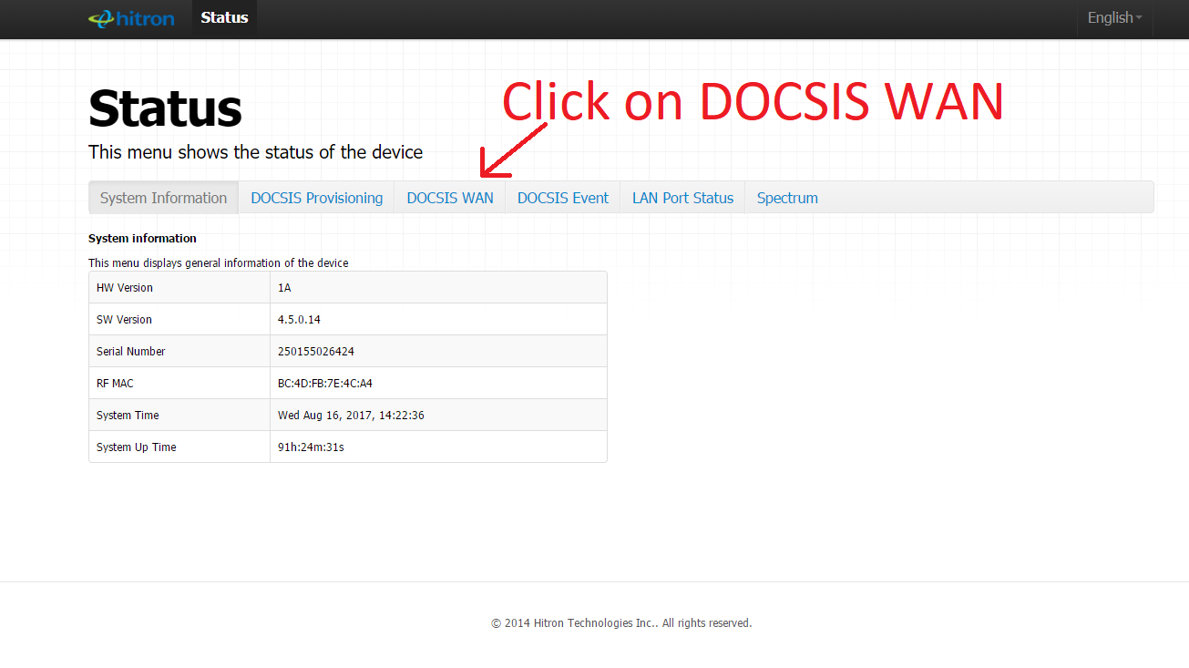
- Press CTRL and A at the same time, then press CTRL and C at the same time (For Apple device, you should use Command key instead of CTRL key)
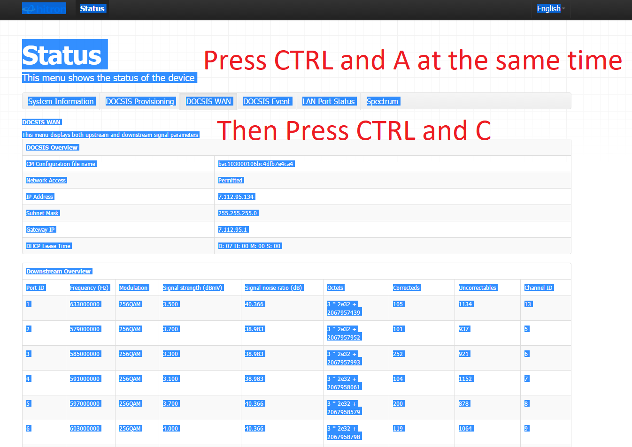
- Open a notepad and paste all
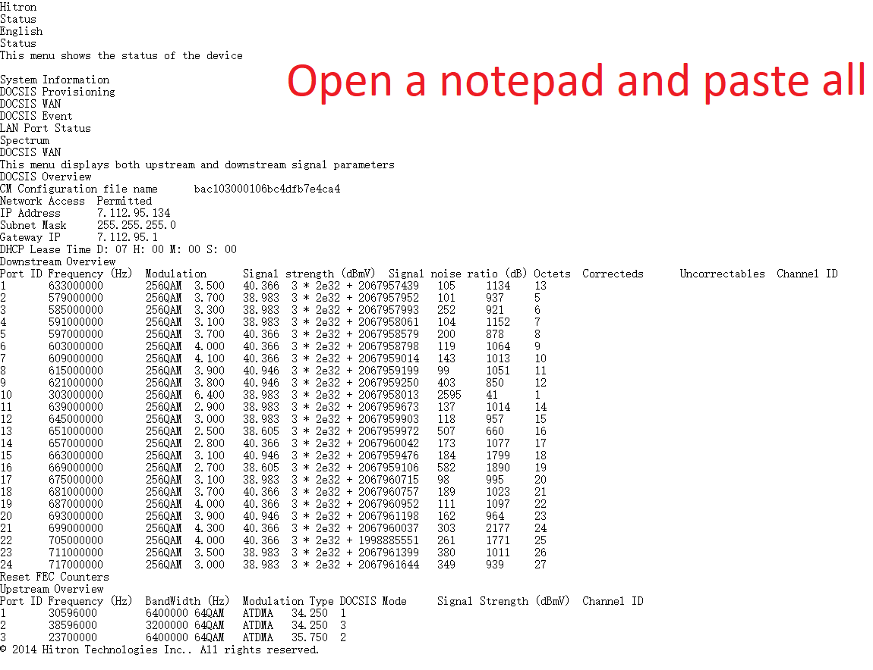
- Go to DOCSIS Event
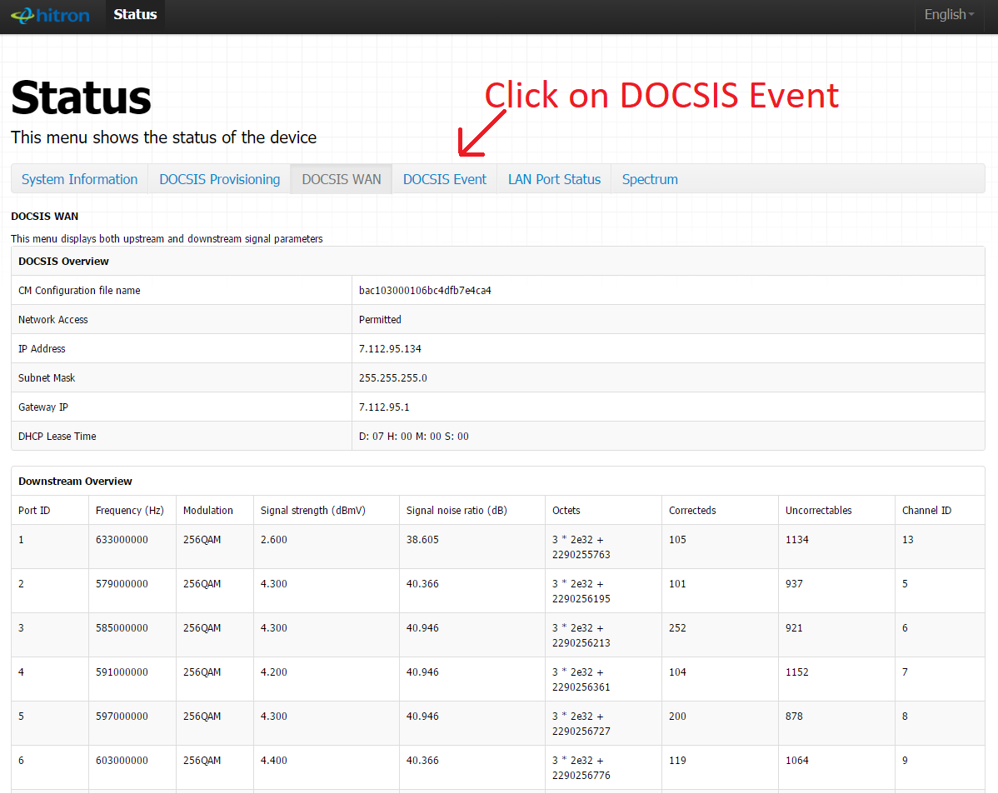
- Press CTRL and A at the same time, then press CTRL and C at the same time (For Apple device, you should use Command key instead of CTRL key)
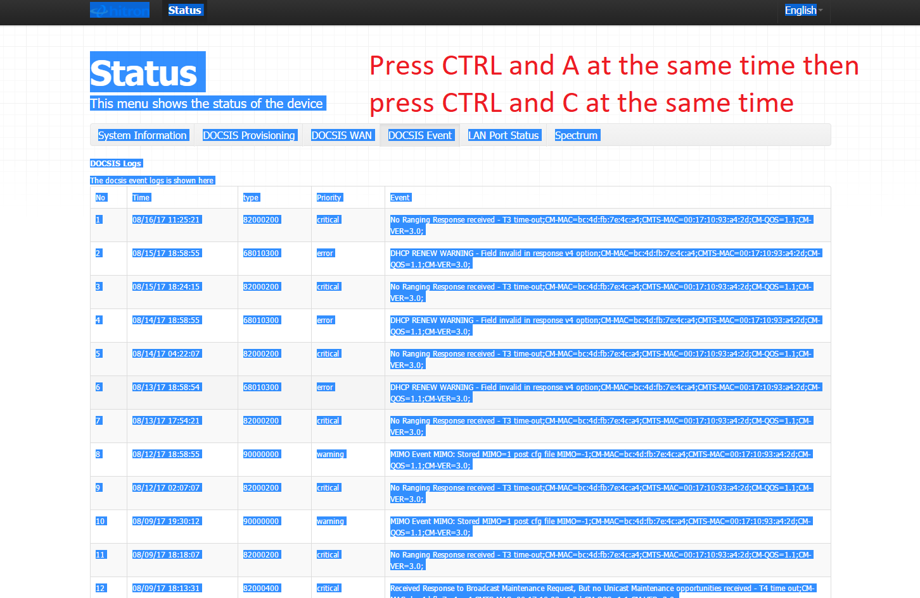
- Open a notepad and paste all
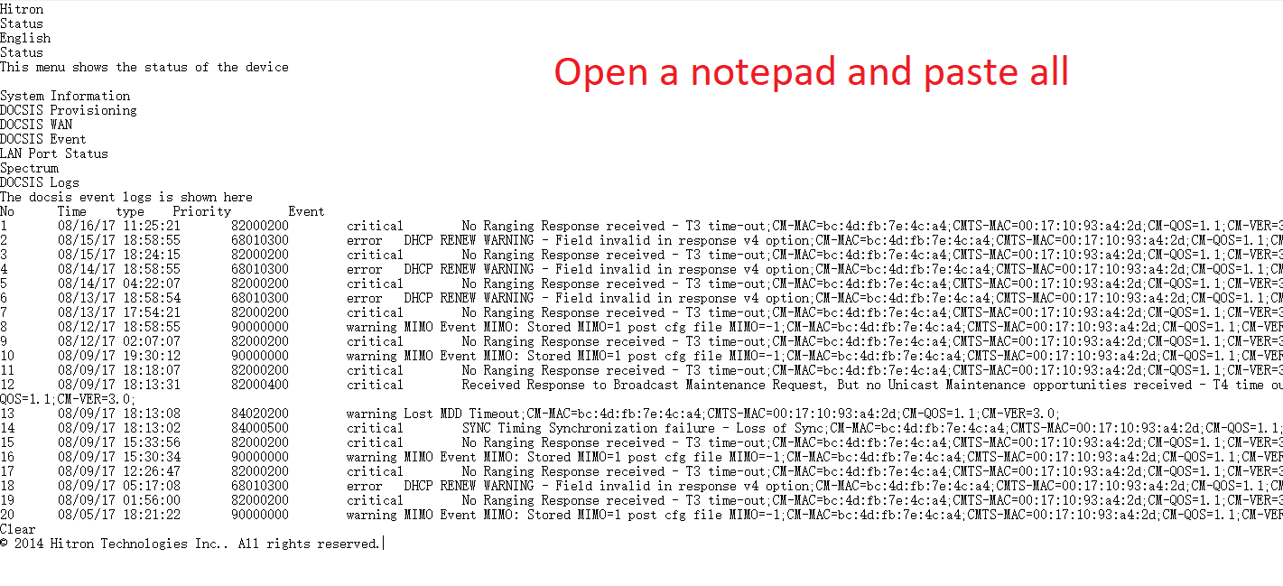
- “ ipconfig” information ( If you are using an Apple device, skip this step and go to step 3)
- Go to desktop, press Windows key and R at the same time. Type cmd and click on OK.
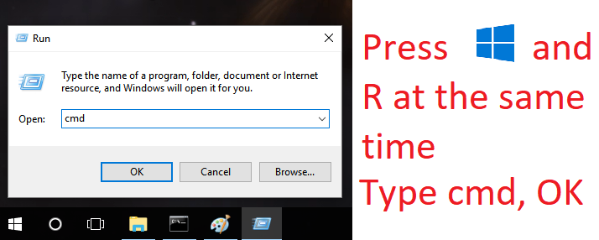
- Type ipconfig /all, then press ENTER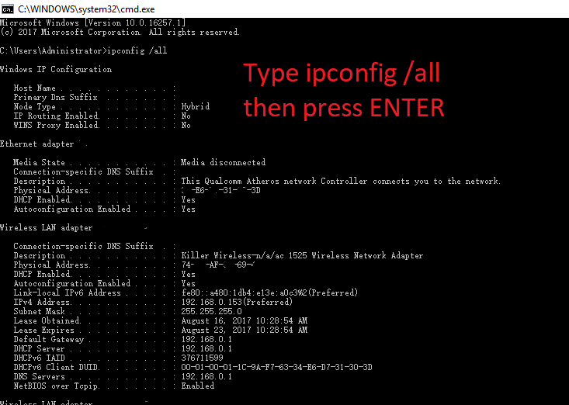
- Right click and click on Select All
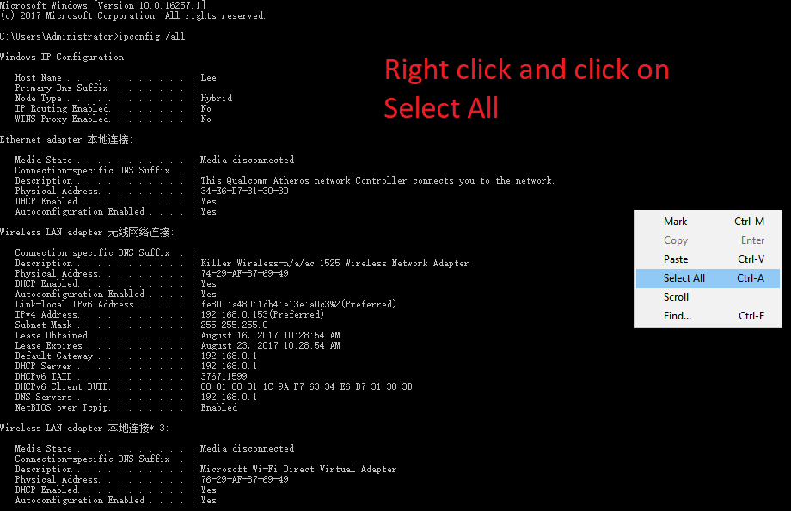
- Move your mouse to the top of the window and right click, click on Edit => Copy
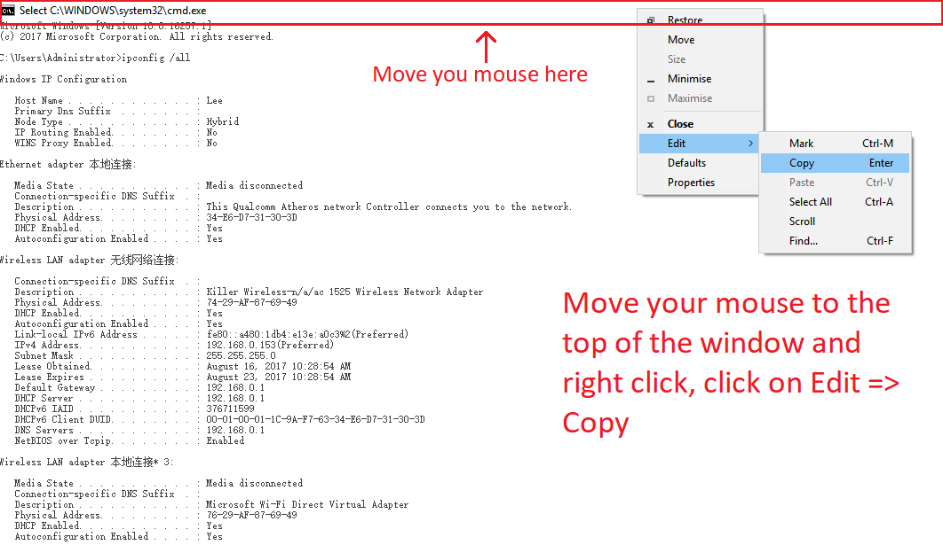
- Open a notepad and paste all
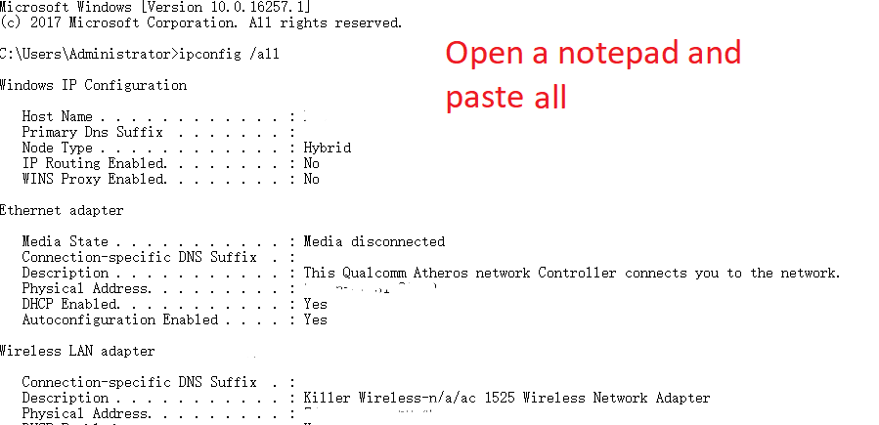
- “ifconfig” information ( If you are using a windows device, skip this and go to step 4)
- Click on Go and click on Utilities
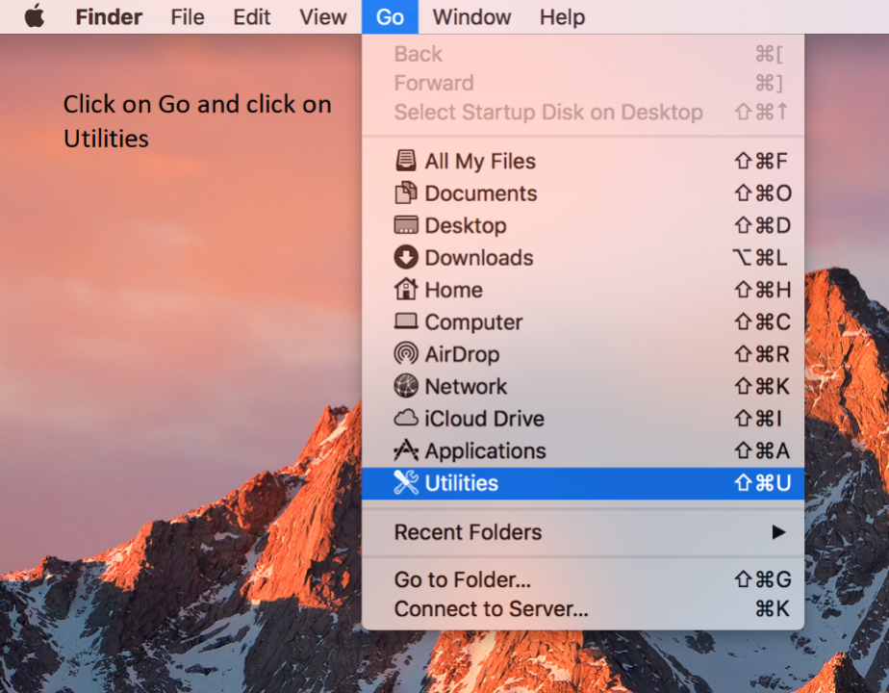
- Open Terminal
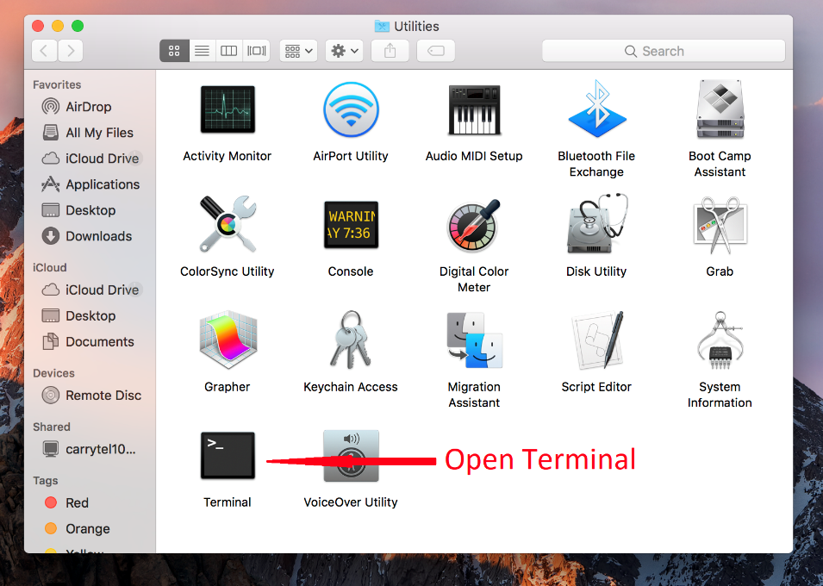
- Press Command and A at the same time, then press Command and C at the same time
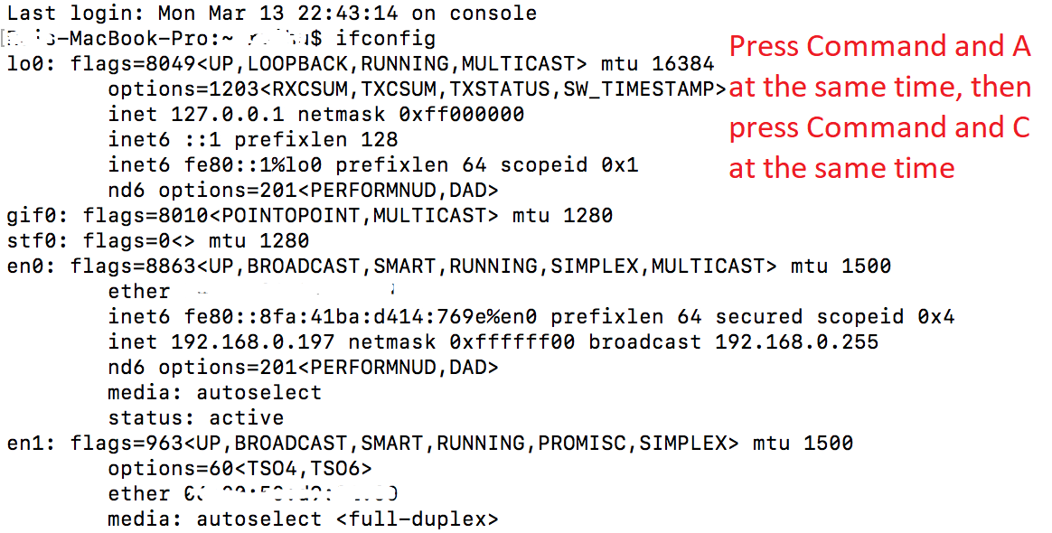
- Type ifconfig and press ENTER
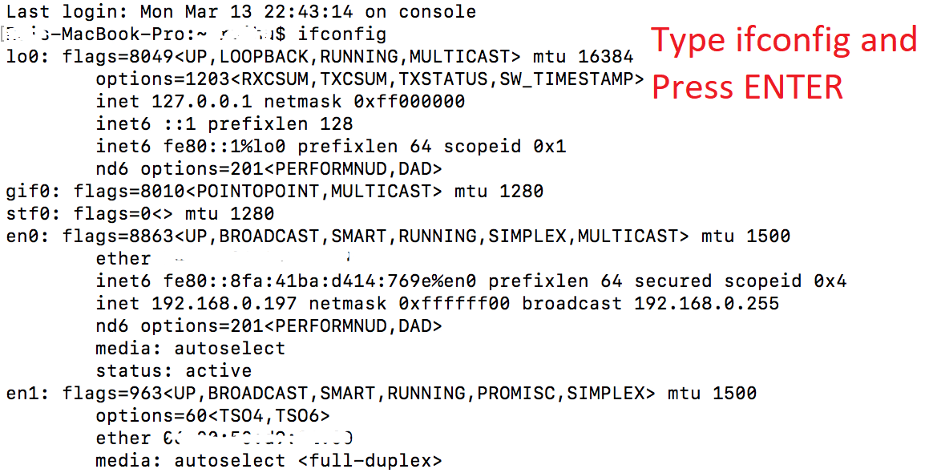
- Open a notepad and paste all
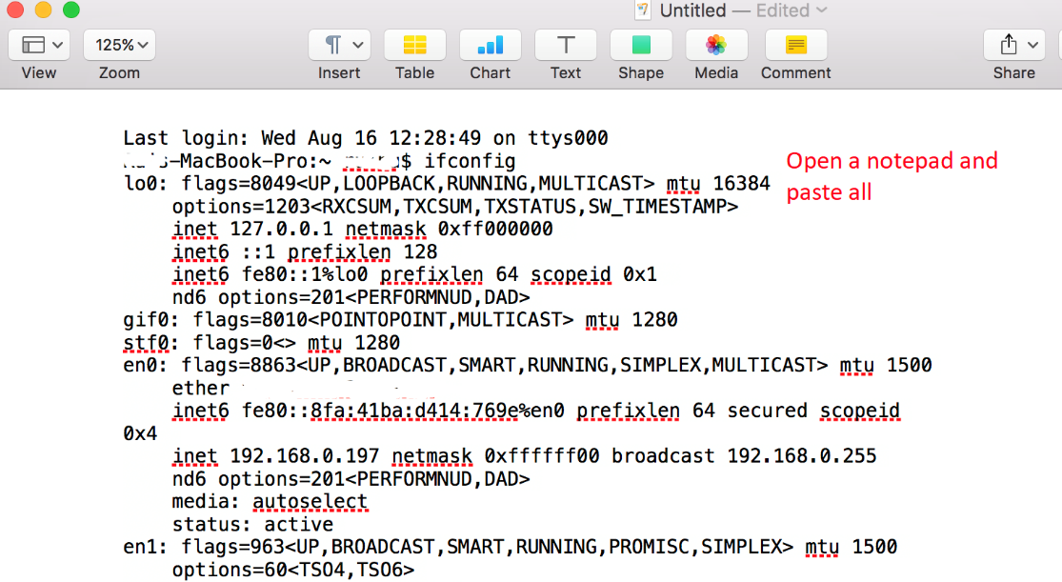
- Save all the information in one document and send to our support e-mail
support@linkcom.ca
Thank you for your cooperation.
Best Regards,
Linkcom Inc.

